**7. Abstract Data Types**

Now we’ll define three ADTs namely [List](https://www.geeksforgeeks.org/linked-list-set-1-introduction/) ADT, [Stack](https://www.geeksforgeeks.org/stack-data-structure-introduction-program/) ADT, [Queue](https://www.geeksforgeeks.org/queue-set-1introduction-and-array-implementation/) ADT.

**8. Running Time of an Algorithm and Big O Notation :**

**Constant , Linear and Quadratic**

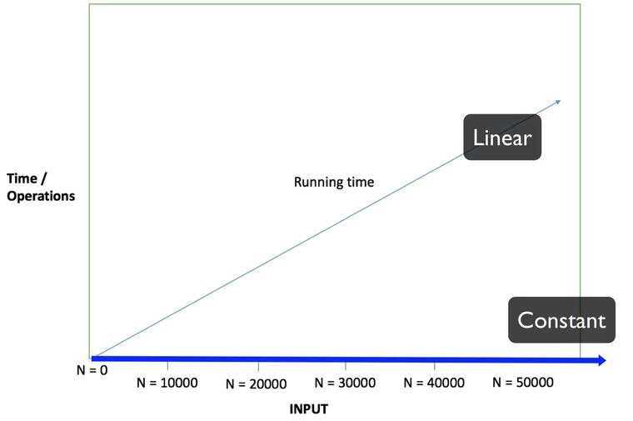

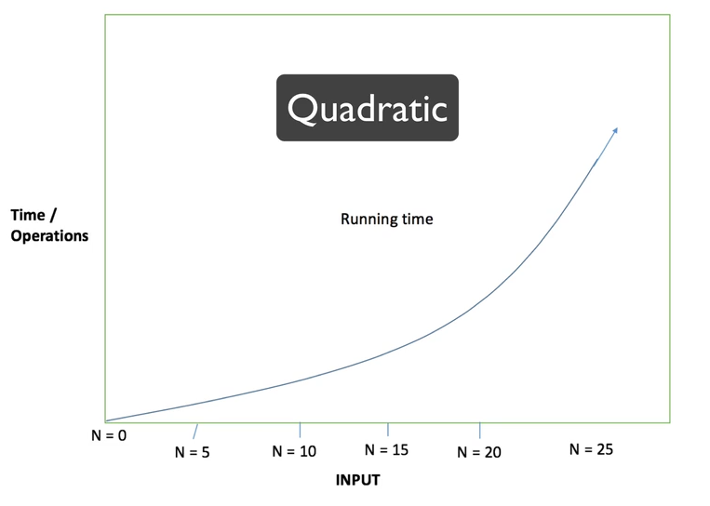

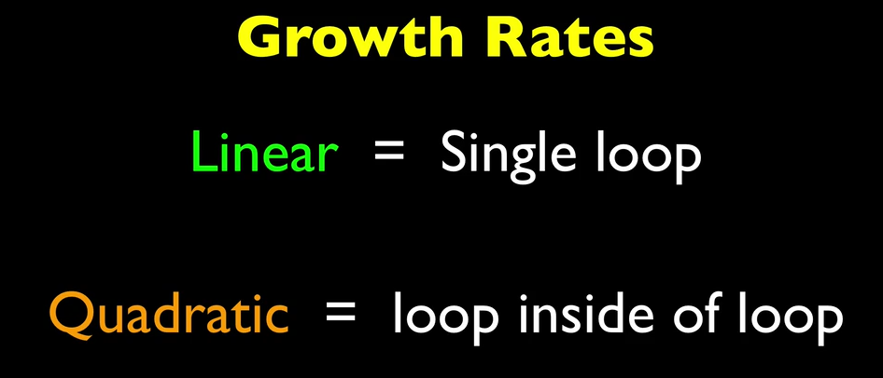

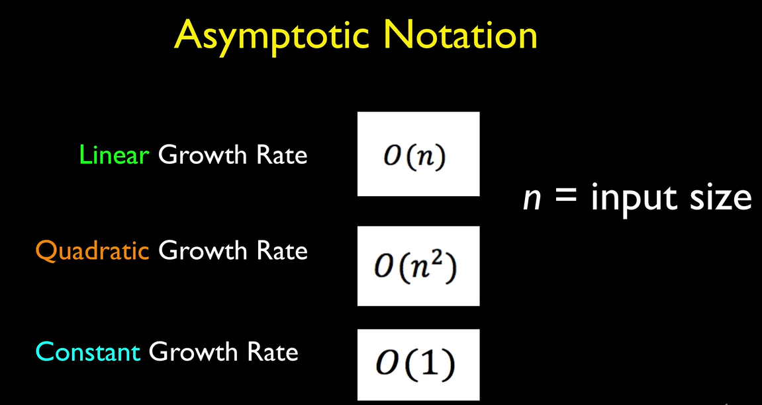

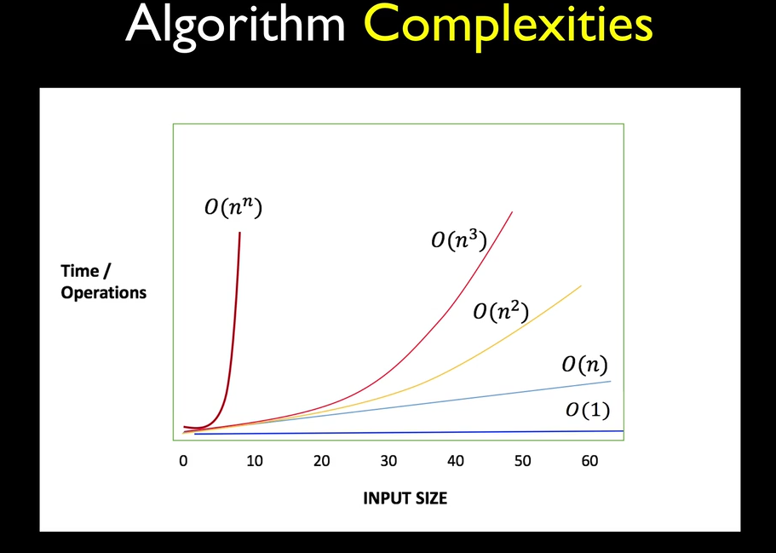

**9. Stack Data Structure**



LIFO (Last In First Out)